COMPANY PROFILE
Карточка предприятия

Full name:  Полное наименование: | Guangzhou Expro Import and Export Trading Co.,Ltd
Abbreviated name:  Сокращенное наименование: | Expro
Legal address:  Юридический адрес: | Office 2928, 2 Huaqiang road, Tianhe District, Guangzhou, China
Postal address:  Почтовый адрес: | Office 2928, 2 Huaqiang road, Tianhe District, Guangzhou, China
Certificate of registration: | 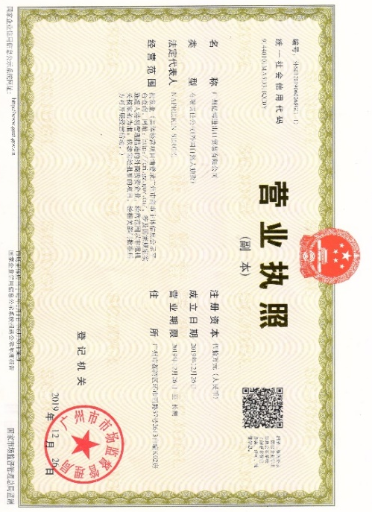
Tel:  Телефон: | +8613178888875  +79993334038
E-mail:  Электронная почта: | Info@expro.biz
Website:  Сайт: | Kitau.ru
Director:  Генеральный директор: | Napreikin Sergei
Bank Information
Bank  Банк: | BANK OF CHINA, GUANGJIAOHUI SUB-BRANCH
Bank Address:  Адрес банка: | HAIZHU DISTRICT NO.382 YUE JIANG ZHONG ROAD, GUANGZHOU, CHINA.
Account (USD)  Банковский счет (USD): | 710776033264
Account (RMB)  Банковский счет (RMB): | 696476040262
SWIFT CODE | BKCHCNBJ400
Director: |  | Sergei Napreikin

